**ANL252**

**Python for Data Analytics**

**Group-based Assignment (GBA01)**

**July 2021 Presentation**

**T09**

**Group 8**

|  |  |
| --- | --- |
| Brandon Tan Xuan Ming | Y1970855 |
| Cheong Jia En, Sandras | N1981099 |
| Muhammad Syairazi Bin Mahdhar | Z1970078 |

Submission Date:

27 August 2021

**Question 1**

**(a)**

# Importing Numpy and Matplotlib

import numpy as np

import matplotlib.pyplot as plt

# Creating array_1 to store the observed data.

array_1 = np.array([[4, 0.2, 1.16],

[6, 0.1, 0.06],

[8, 0.3, -1.79],

[4, 0.6, 1.55],

[10, 0.1, -4.88],

[1, 0.4, 1.37],

[9, 0.6, -1.25],

[5, 0.3, -1.1],

[2, 0.5, 3.23],

[7, 0.5, -2.71],

[8, 0.1, -0.99],

[2, 0.9, 3.23],

[2, 0.8, 4.55],

[8, 1, 2.7],

[7, 0.9, -1.13],

[9, 0.1, -0.88],

[1, 0.2, 2.08],

[4, 0.2, 1.62],

[6, 0.7, -0.9],

[9, 0.7, 0.46]])

# Printing array_1

print(f'The array_1 Array is: \n{array_1}')

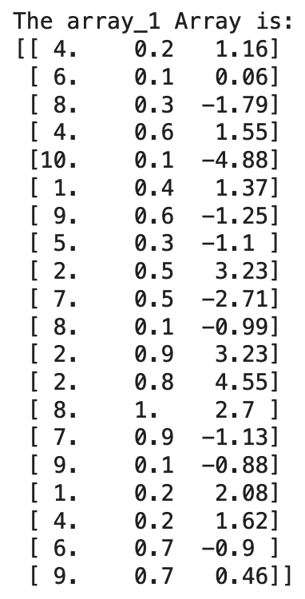

**(b)**

# Let y_hat be the predicted value of y.

# Let y_hatarr be an initialised 1 x 20 array to store all the y_hat values.

y_hatarr = np.zeros(20)

# The loop here calculates the y_hat value from each row in array_1, and stores it in y_array.

t_1 = 0

while t_1 < 20:

for a in array_1:

y_hat = 2 - 0.5*a[0] + 2.5*a[1]

y_hatarr[t_1] = y_hat

t_1 += 1

# Printing y_hatarr

print(f'The y_hatarr Array is: \n{y_hatarr}')

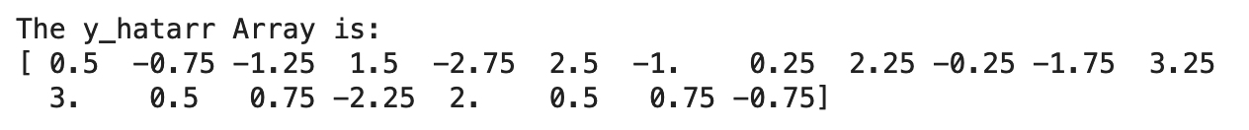

**(c)**

# Let e_hat be the value when the y column in array_1 subtracts each y_hatarr value.

# Let e_hatarr be the array to store each e_hat value.

e_hatarr = array_1[0:, 2] - y_hatarr

# Printing e_hatarr

print(f'The e_hatarr Array is: \n{e_hatarr}')



**(d)**

# Generating the Histogram using e_hatarr for the Residual Distribution.

plt.hist(e_hatarr, range = (-2.5, 2.5), bins = 10, rwidth = 0.8, color = 'darkblue', align = 'mid')

plt.xlabel('Residual Values')

plt.ylabel('Frequencies')

plt.title('Residual Distribution')

plt.xticks(ticks = [-2.5, -2.0, -1.5, -1.0, -0.5, 0, 0.5, 1.0, 1.5, 2.0, 2.5],

labels = [-2.5, -2.0, -1.5, -1.0, -0.5, 0, 0.5, 1.0, 1.5, 2.0, 2.5])

# Displaying the Histogram

plt.show()

# Finding the mean of the Residual Distribution via the Numpy function.

# We then compare the mean to 0, and print our findings.

mean = np.mean(e_hatarr)

if mean == 0:

print('The mean of the Residual Distribution is 0.')

else:

print(f'The mean of the Residual Distribution is not 0. It is {mean:.4f}')

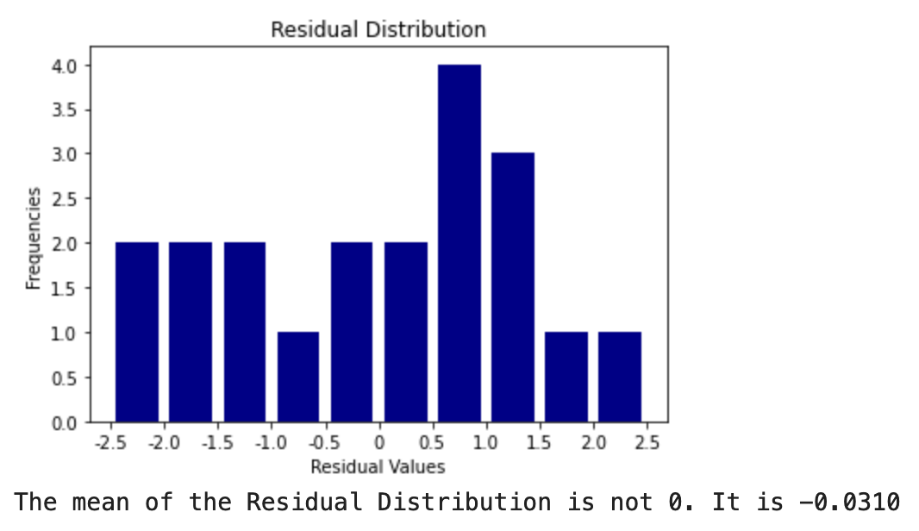

**(e)**

# Generating a Scatter Plot using values from y_hatarr as the x-axis and the values from e_hatarr as the y-axis.

plt.scatter(y_hatarr, e_hatarr, color = 'red', marker = 'o', edgecolor = 'black')

plt.xlabel('Predicted Values, Ŷ')

plt.ylabel('Residual Values, ê')

plt.title("Correlation between Predicted Values Ŷ and Residual Values ê")

plt.xticks(ticks = [-4.0, -3.0, -2.0, -1.0, 0, 1.0, 2.0, 3.0, 4.0],

labels = [-4.0, -3.0, -2.0, -1.0, 0, 1.0, 2.0, 3.0, 4.0])

plt.yticks(ticks = [-3.0, -2.0, -1.0, 0, 1.0, 2.0, 3.0],

labels = [-3.0, -2.0, -1.0, 0, 1.0, 2.0, 3.0])

plt.grid(True)

# Displaying the Scatter Plot

plt.show()

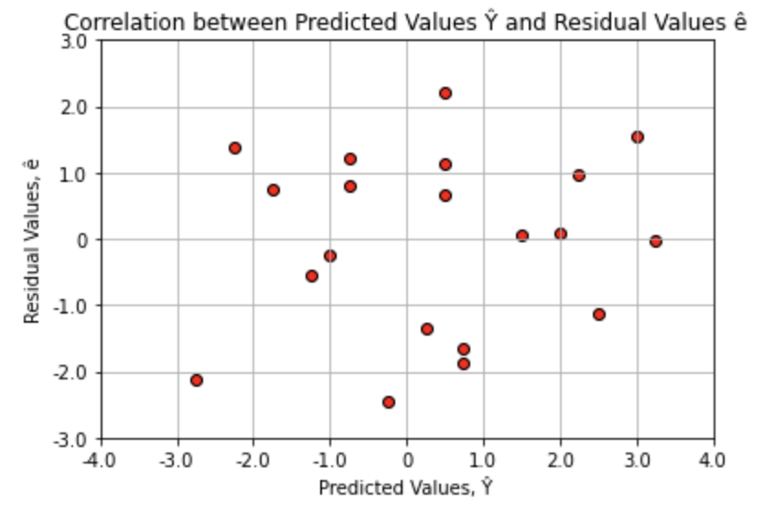

The scatter plot does not have any regular pattern, and neither are all the points lying on the same level. To the right, the extreme point is near (3, 0). To the left, the extreme point is near (-3, -2). To the top, the extreme point is near (0.5, 2). And to the bottom, the extreme point is near (0, -2.5). In between, the other points are scattered without any bias toward a specific direction. Therefore, we can conclude that there is no constant variance.

**Question 2**

import pandas as pd

df_class = pd.read_csv("class.csv")

df_class

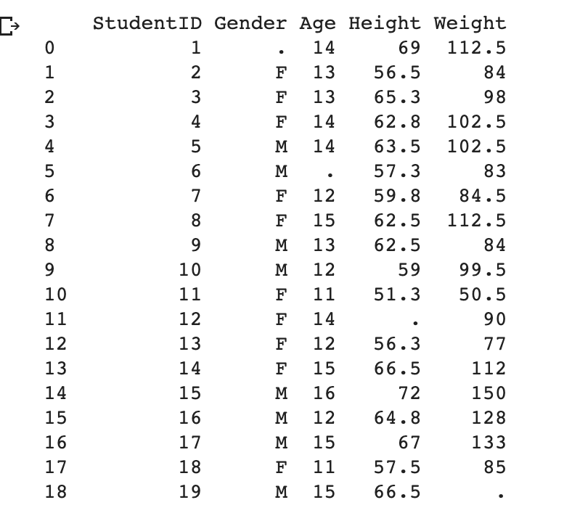

# Specify missing values that were "." to NaN

df_class = pd.read_csv("class.csv", na_values = ".")

display(df_class)

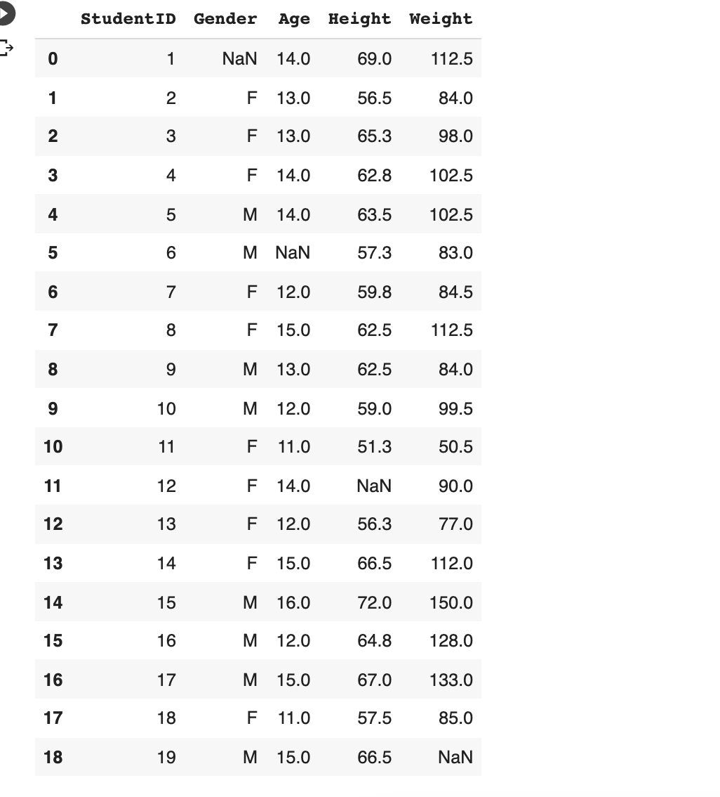

# Sorting Age in descending order and Gender in ascending order (alphabetical order)

df_class.sort_values(['Age', 'Gender'], ascending=[False, True])

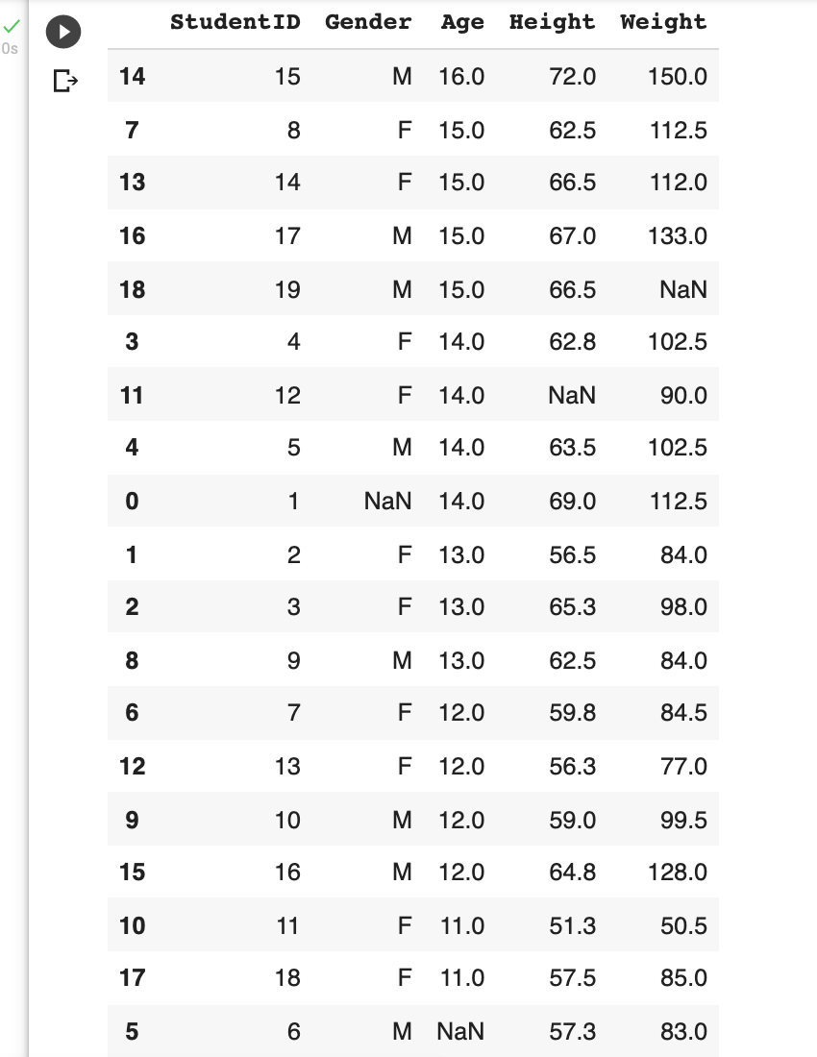

import numpy as np

# Check every column and row and return the sum of Nan for each column and each row

column = df_class.isnull().sum(axis = 0)

row = df_class.isnull().any(axis = 1)

missingrow = np.where(row)[0]

print(f"Columns with missing values are: \n{column}\n")

print(f"Rows with missing values are: ")

for i in missingrow:

print(i)

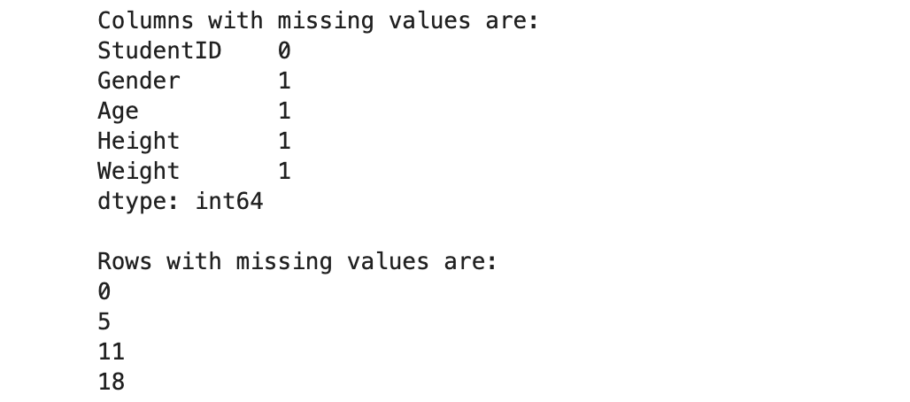

The output above shows the columns and rows with missing values. Therefore, missing data are found in the columns “Gender”, “Age”, “Height” and “Weight”, and in rows 0, 5, 11 and 18.

# Replace missing values by gender with highest frequency

df_class["Gender"].fillna(df_class["Gender"].mode()[0], inplace = True)

# Replace missing values by median age

df_class["Age"] = df_class["Age"].fillna(df_class["Age"].median())

# Replace missing values by mean height

df_class["Height"] = df_class["Height"].fillna(df_class["Height"].mean())

# Replace missing values by mean weight

df_class["Weight"] = df_class["Weight"].fillna(df_class["Weight"].mean())

# Rounding

df_class.round({"Age": 0, "Height": 4, "Weight": 4})

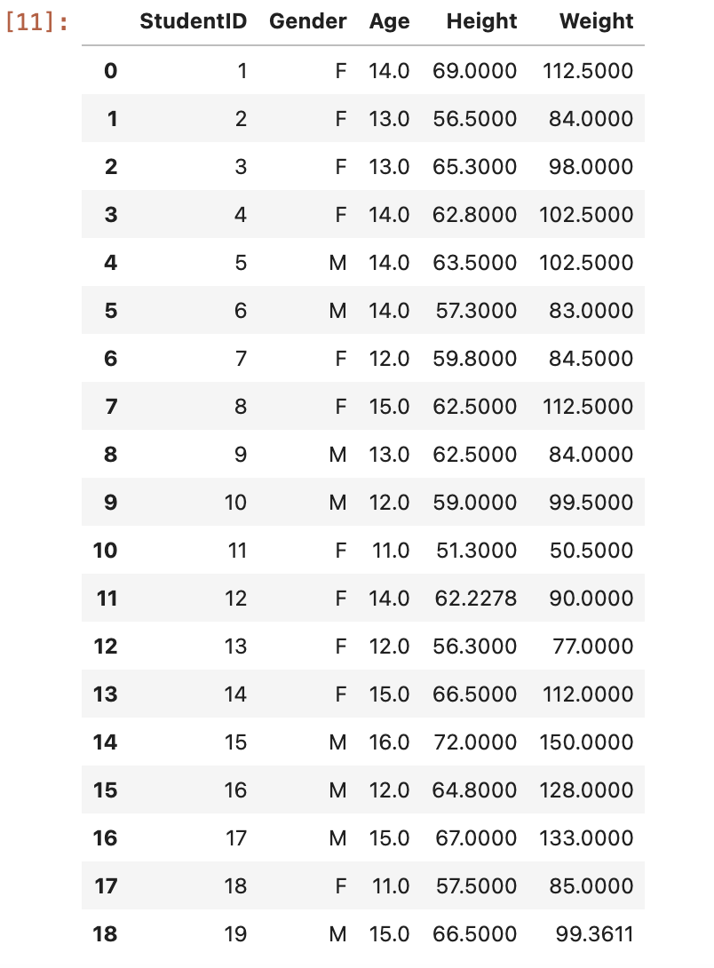

# Detecting outliers with Interquartile Range (IQR)

# Calculating IQR for each column

q1 = df_class.quantile(0.25)

q3 = df_class.quantile(0.75)

iqr = q3 - q1

print(f"{iqr}\n")

# True indicates presence of an outlier

# False indicates the values are valid

lowerbound = q1 - 1.5 * iqr

upperbound = q3 + 1.5 * iqr

print((df_class < lowerbound) | (df_class > upperbound))

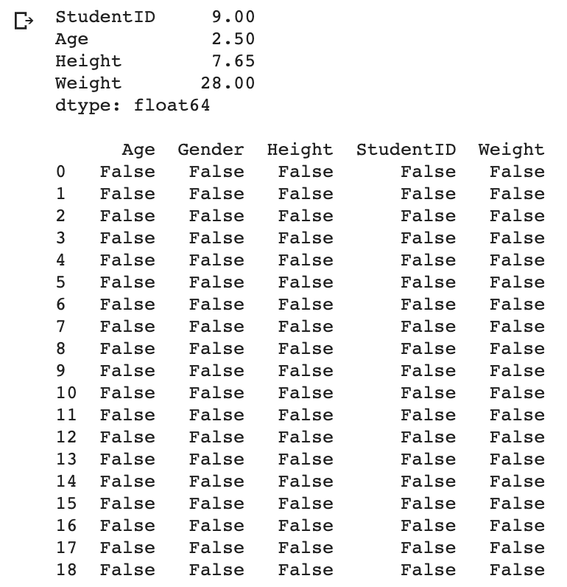

The returned output indicates that there are no outliers detected as evident where all values are valid and represented by “False”. Therefore, there is no need to delete any rows.

**Question 3**

An **inner join** between two dataframes involves intersecting their datasets while an **outer join** involves the union of the two dataframes.Inner join returns a dataframe with only rows that have matching keys in the joint table (DataScience Made Simple, 2020). A full outer join returns all rows and joins records of matching keys in the two tables where Nan is returned when there is no match (DataScience Made Simple, 2020). Likewise, a **left join** will return all rows from the left table and any rows with matching keys from the right table where Nan will be returned if there is no match, and vice versa for a **right join** (DataScience Made Simple, 2020).

The various joins can be performed with a **merge() function** which is part of the pandas package, taking both dataframes as arguments (Sharma, 2020). It does an inner join by default where other joins i.e., outer, left, right can be specified with the ‘how’ parameter, and users have control over which columns to combine on with the ‘on’ parameter (Stratis, n.d.). ‘left_on’ and ‘right_on’ are arguments applicable when there is a need to specify different column names in the two dataframes (Sharma, 2020).

(197 words)

**References**

DataScience Made Simple. (2020, December 24). *Join in Pandas: Merge data frames (inner, outer, right, left join) in pandas python*. Retrieved from<https://www.datasciencemadesimple.com/join-merge-data-frames-pandas-python/>

Sharma, A. (2020, February 27). *Joins in Pandas: Master the Different Types of Joins in Python*. Retrieved from<https://www.analyticsvidhya.com/blog/2020/02/joins-in-pandas-master-the-different-types-of-joins-in-python/>

Stratis, K. (n.d.). *Combining Data in Pandas With merge(), .join(), and concat()*. Retrieved from<https://realpython.com/pandas-merge-join-and-concat/>